Recycled Heat — NEWPCC Clean Hybrid Portfolio vs the Brandon dispatchable capacity project
Executive brief One page · August 2026
How Manitoba can bridge its 2030 winter shortfall with a recycled-heat and battery hybrid approach — for billions less than a new gas plant.
Hydro seeks ~$3 billion for new Brandon gas turbines while its existing units failed or derated in 3 of 10 peak winter events, including 22–20 January 2025 at 5,111.5 MW [PD]. Manitoba’s energy use is highest in winter, and that peak keeps going up. As a result, Hydro expects a 600 MW drought-year shortfall by 2030 [PD]. A new Brandon gas plant is one proposed answer. Our alternative recovers sewage heat, adds batteries, uses demand response, and counts interties on their own terms: 413–788 MW electric for $1.95B gross ($1.50B if ITC confirmed), with non-overlapping twenty-year costs vs gas — with zero compute credit in any scenario. Winnipeg is rebuilding NEWPCC for $3.17 billion [PD]. Funding agreements cover the first two projects; however, Project 3 has no funding agreement [PD]. Recovery taps must be designed in now or the heat is wasted. Public compute, PDRC films, and a ground battery complement the hybrid; they are not contingent on it. Summer relief (~50 MW roof cooling + 70 MW ground storage) is a separate seasonal book — not winter firm, and not an export forecast.
Decision | Brandon gas | Clean hybrid
Capital | $3.0B | $1.95B / $1.50B net
Overnight $/kW | $4,000 nameplate | $2,834 / $2,180 at 688 MW
Firm electric | 750 MW nameplate; 525 MW scenario | 413 / 688 / 788 MW
20-year all-in | $4.5–6.9B | $1.5–1.8B net of ITC · save $2.7–5.4B
Seven orders — the ask
- Head-to-head hybrid (incl. sewage heat) vs gas — LOLE / ELCC / $/kW-year — before any capital certificate, including whether a 2030 peaker still leaves Hydro’s next northern station off the path.
- Independent cold-weather audit at ≤ −30 °C; identical ELCC rules for both plans.
- Machine-readable cost models from both parties.
- Disclose interconnection headroom near screened anchors + extreme-event logs.
- Preserve NEWPCC trench / effluent heat-recovery option while contracts are open.
- Measured heat pilot at the effluent-stage hub, with public metered filings.
- Authorize public heat-first compute in the locked 10–20 kW band — not contingent on pre-cleared gates.
Same arithmetic, before the concrete. The Board need not adopt our numbers — only insist both plans face the same test in public. What follows is one paper in one voice for citizens and regulators; the mathematical appendix at the end is for advisors who must check every substitution.
1. Manitoba doesn’t need another gas plant. It needs heat that does double duty.
Manitoba’s energy use is highest in winter, and that peak keeps going up. As a result, Manitoba Hydro expects a shortfall of about 600 megawatts by 2030 [PD]. Its Brandon gas turbines, which are supposed to help during those times, failed or were limited during three of the ten biggest winter peaks in the last decade — a record Winnipeg Free Press reporting by Malak Abas confirmed from Public Utilities Board testimony, including 22–20 January 2025, when demand reached 5,111.5 MW [PD].
Despite this track record, Hydro is seeking approximately $3 billion for new Brandon turbines, promising near-perfect reliability. CEO Allan Danroth told the Board the turbines are “necessary.” Finance Minister Adrien Sala referred the project to the PUB. The operational history does not support that promise.
While new equipment may be more advanced, the 3-of-10 record is existing units; it is not itself a prediction about unbuilt turbines. Cold-weather fuel supply and start limitations still deserve explicit modelling. This approach also overlooks Manitoba’s primary challenge — our peak demand is for heating. If homes are electrified without proper planning at −35 °C, air-source heat pumps revert to resistance coils, exacerbating the very shortage Hydro aims to address by burning more gas.
Manitoba already has a multi-day solution: northern reservoirs provide substantial multi-day stored energy, including under drought planning conditions [PD/A]. The remaining problem is coincident winter power. The 2024 peak already ran ~300 MW above drought-planning hydro, covered by imports and non-hydro resources, which is exactly the slack the 2030 shortfall consumes. The system does not lack weeks of energy, but rather a few hundred megawatts of power during the coldest mornings and evenings.
The hybrid is a 2030 coincident-power bridge for that hour. Conawapa-class hydro is Hydro’s later capacity path, not a 2030 machine and not on the winter stack. Gas is not needed if Order 1 shows the hour without new turbines. Conawapa is not added to 413 / 688 / 788.
The full 600 MW is Hydro’s drought-year supply gap for 2030 [PD]. Hydro has not said how much of that shortfall is due to heating compared to other causes. Dual-fuel — heat pump most days, furnace on the coldest nights — is the main plan, and that path adds no extra peak. Converting 15% of Manitoba’s gas-heated homes with furnaces off at −35 °C would add an estimated 675 MW to the extreme-cold peak [E] that is a risk identity, not a share of the 600.
Hydro’s 2025 IRP Appendix 7.2 Table A7.2.2 is cumulative installed capacity additions to 2032, not a bridge of the 600. The CT — Natural Gas row is 496 MW in S1A/S1B (Baseline) and 744 MW in S2B (Medium, net-zero grid 2035). 744 − 496 = 248 MW extra turbines when load moves Baseline to Medium, not heating alone, and not the 600 MW gap.
Our own growth projections reveal a different number. From the 20 January 2025 record, at 1.2% a year through 2030: 5,111.5 × 1.012⁵ ≈ 5,426 MW, and 5,426 − 5,111.5 ≈ 314 MW. That 314 MW is peak-load growth from the record. It is not the 600. The question is not whether to act, but what to invest in.
What makes that worth arguing about is what Manitoba already holds. More than 96% [O] of the province’s electricity comes from water, and the grid carries roughly 1.3 g CO₂e/kWh [O] — among the lowest figures measured anywhere on Earth, and two to three orders of magnitude below a fossil-heavy grid. That is the inheritance actually at stake, and it is not only the electricity. It is the land, the soil and the water the system was built on, and Lake Winnipeg downstream of all of it.
The lake is already paying. Phosphorus reaching it runs about 3,050 t P/yr [E] against a 1,400 t binational border objective [O]. The North End rebuild recovers roughly 130 t [E] — about 4% of the gap. So Manitoba is being asked to carry two three-billion-dollar debts at once: gas turbines at Brandon [PD], and the North End rebuild in Winnipeg [PD]. Neither is asked to answer for the other, and the cleanest grid on the continent is what both are spending against.
We see this fundamentally as a waste management and accounting issue, not a generation problem. Manitoba has sufficient clean energy but loses heat at its wastewater treatment facilities, pools and skating rinks, and under-utilizes flexible loads during peak hours. It has also historically combined heat and electric megawatts in its reporting — thermal megawatts summed into electric headlines that could not survive an audit. Import capability exists but is counted at zero until deliverability is proven. The remedy this filing proposes is waste management and waste accounting: recover the heat that is already there, shift the load that is already flexible, count every megawatt once on its own ledger — and only then ask what, if anything, still needs to be built. Gated public compute is the optional tenant in that system: it can pay the heat recovery to exist and bank its reject heat for winter, but it buys its way in with contracts and curtailability, never with credit it has not earned. On this arithmetic the planning case bridges 600 MW on nameplate only if 150 MW of unfilled demand response and 200 MW of undemonstrated winter import both show. 488 MW and 413 MW do not. The hybrid is a 2030 coincident-power bridge. Conawapa-class hydro is Hydro’s later capacity path, not a 2030 machine and not on the winter stack. Gas is not needed if Order 1 shows that hour without new turbines. The gas plant is not the answer to the problem; it is the receipt for not managing the waste.
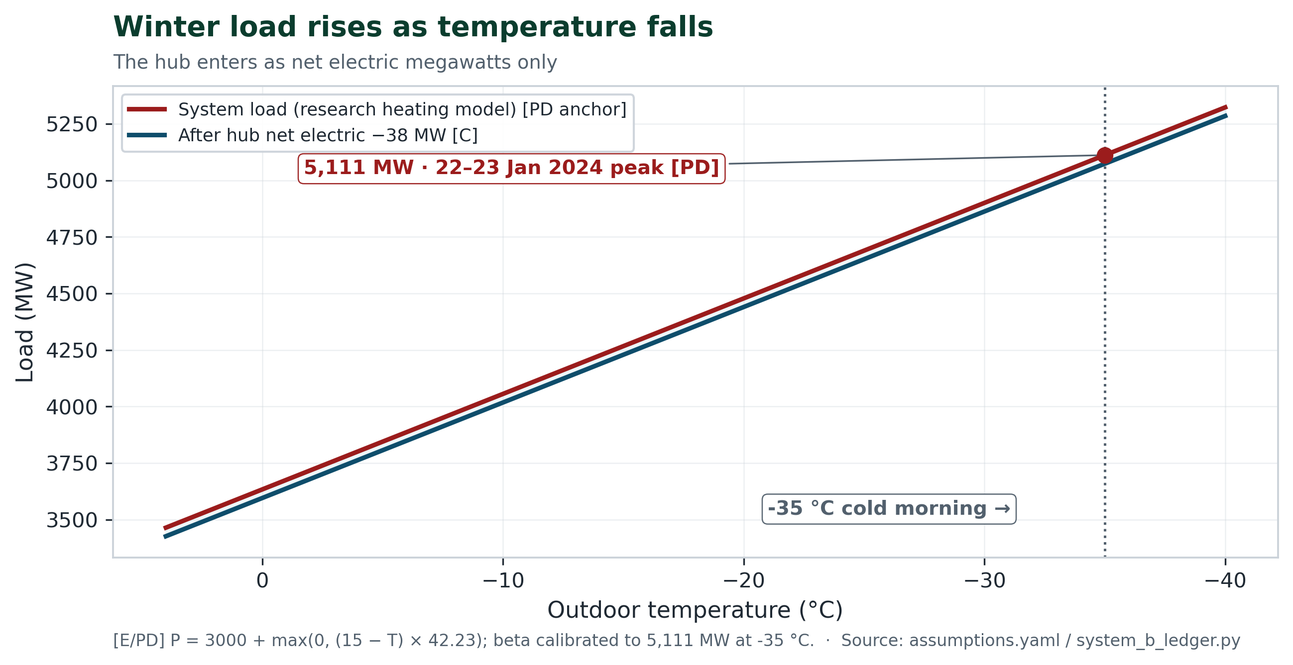
Figure 1 — Winter load rises as temperature falls. Peak anchor 5,111.5 MW [PD]. Hub enters only as net electric MW.
2. Two $3-billion choices, one wastes heat forever
Here is the absurdity hiding in plain sight.
The province is currently debating a $3-billion gas plant in Brandon. Winnipeg is already building a $3.17 billion project: modernising the North End Water Pollution Control Centre — the largest capital project in the city’s history. Funding agreements cover the first two projects; however, Project 3 has no funding agreement [PD]. NEWPCC already treats about 70% of Winnipeg’s wastewater. Sewage carries low-grade heat every hour of every season. Vancouver’s False Creek has heated buildings this way for more than a decade. On a −35 °C morning, every megawatt of that heat that reaches a radiator is one less megawatt Hydro must generate for electric heating. Use the same energy, twice.
If we miss the window then Winnipeg gets a plant that treats water well and wastes heat forever. But if we act now while contracts are open, then the North End can host low-carbon heat for a generation — without asking ratepayers to fund another fossil fuel plant — and we can start saving and better accounting for our energy.
Decision | Brandon gas | NEWPCC clean hybrid
Capital | $3.0B | $1.95B gross ($1.50B if ITC confirmed)
Overnight $/kW | $4,000/kW nameplate | $2,834 / $2,180 at 688 MW planning
What counts as firm | 750 MW nameplate; 525 MW only as scenario | 413 / 688 / 788 MW electric by accreditation
Heat | — | 50 MWth effluent hub (+95 MWth gated); +38 MW net electric
20-year all-in | $4.5–6.9B | $1.5–1.8B net of ITC · savings $2.7–5.4B
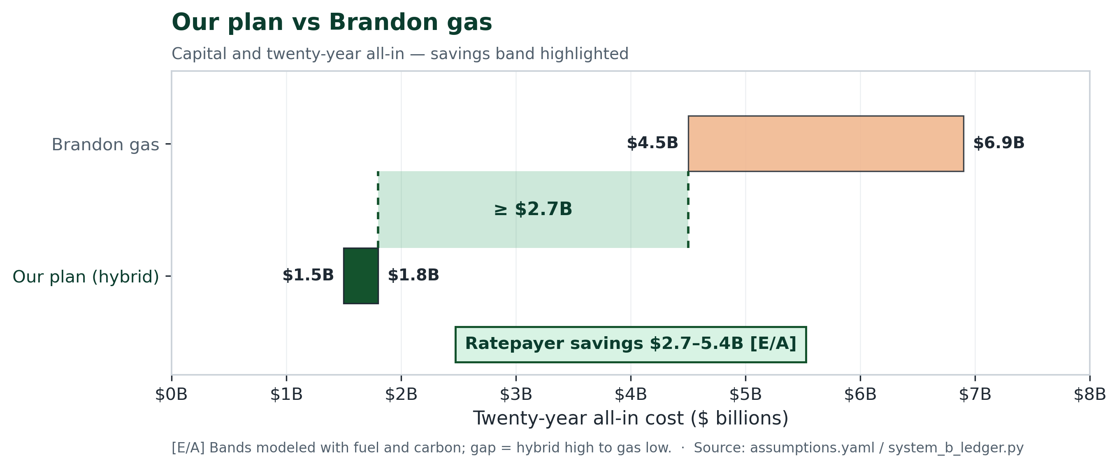
Figure 2 — Our plan vs Brandon gas: twenty-year all-in bands with the ratepayer savings gap highlighted [E/A].
This plan concentrates everything on one station and one fuel. Current units at that site were failed or limited during three of the ten worst winter peaks of the last decade [PD].
That is our solution: a heat-pump and battery answer to a heat problem — not a gas-plant answer to a spreadsheet problem.
3. Our plan: sewage heat, batteries, demand response, interties
Think of five pieces working together — not one giant machine replacing Brandon.
- Sewage heat at NEWPCC (the base). Pump heat already in the North End plant’s treated water into a district loop: the 38 MW grid benefit is an upper bound — it counts only if the 50 MWth displaces coincident electric resistance, and buildings still on gas would add the 12 MW compressor load instead — and the water stays warm in January with or without compute. MWTH
- 300 MW batteries (4 hours). A 300 MW, four-hour pack covers 7–9 a.m. and 5–7 p.m. — 300 MW × 2 h + 300 MW × 2 h = 1,200 MWh. The pack must recharge between critical days; Hydro has to show it can; an 85% haircut is not dependable capacity.
- 150 MW prospective demand response. A planning target [E] for residual peak after the loop, not a contracted resource, and not the 38 MW already displaced.
- Interties up to 300 MW. Planning counts 200 of 300 MW as 300 × 2/3 — a cold-hour convention, not an ELCC study; 29% of 688, 488 MW without it, zero until Order 1 proves a neighbour can deliver. That 200 MW of dependable imports during Manitoba’s winter peak has not been demonstrated in this filing; imports must not be counted twice against Hydro’s baseline, and reservoir or export benefits from lower domestic demand cannot be counted in the same hour as an import [A].
- Small public compute, a potential benefit off the winter stack. Small 10–20 kW public nodes could sit on the heat loop, heat-first, off at 7–9 a.m. and 5–7 p.m.: still 0 MW on 413 / 688 / 788. If it grew, the same loop could take 95 MWth of reject heat, still 0 MW winter-firm until metered — compute does not eat the 600 MW shortfall. Eligible today: 0 MW [C].
DUAL-LEDGER RULE
Heat megawatts are not electricity megawatts. We never add them — and compute reject heat is never booked as firm supply, because the load that makes it must be netted first. The honest winter electric range is 413 / 688 / 788 MW, built on the effluent-stage hub only. Summer’s ~120 MW PDRC/BTES shave is a separate seasonal book — never padded into winter firm. Substitutions are in the mathematical appendix.
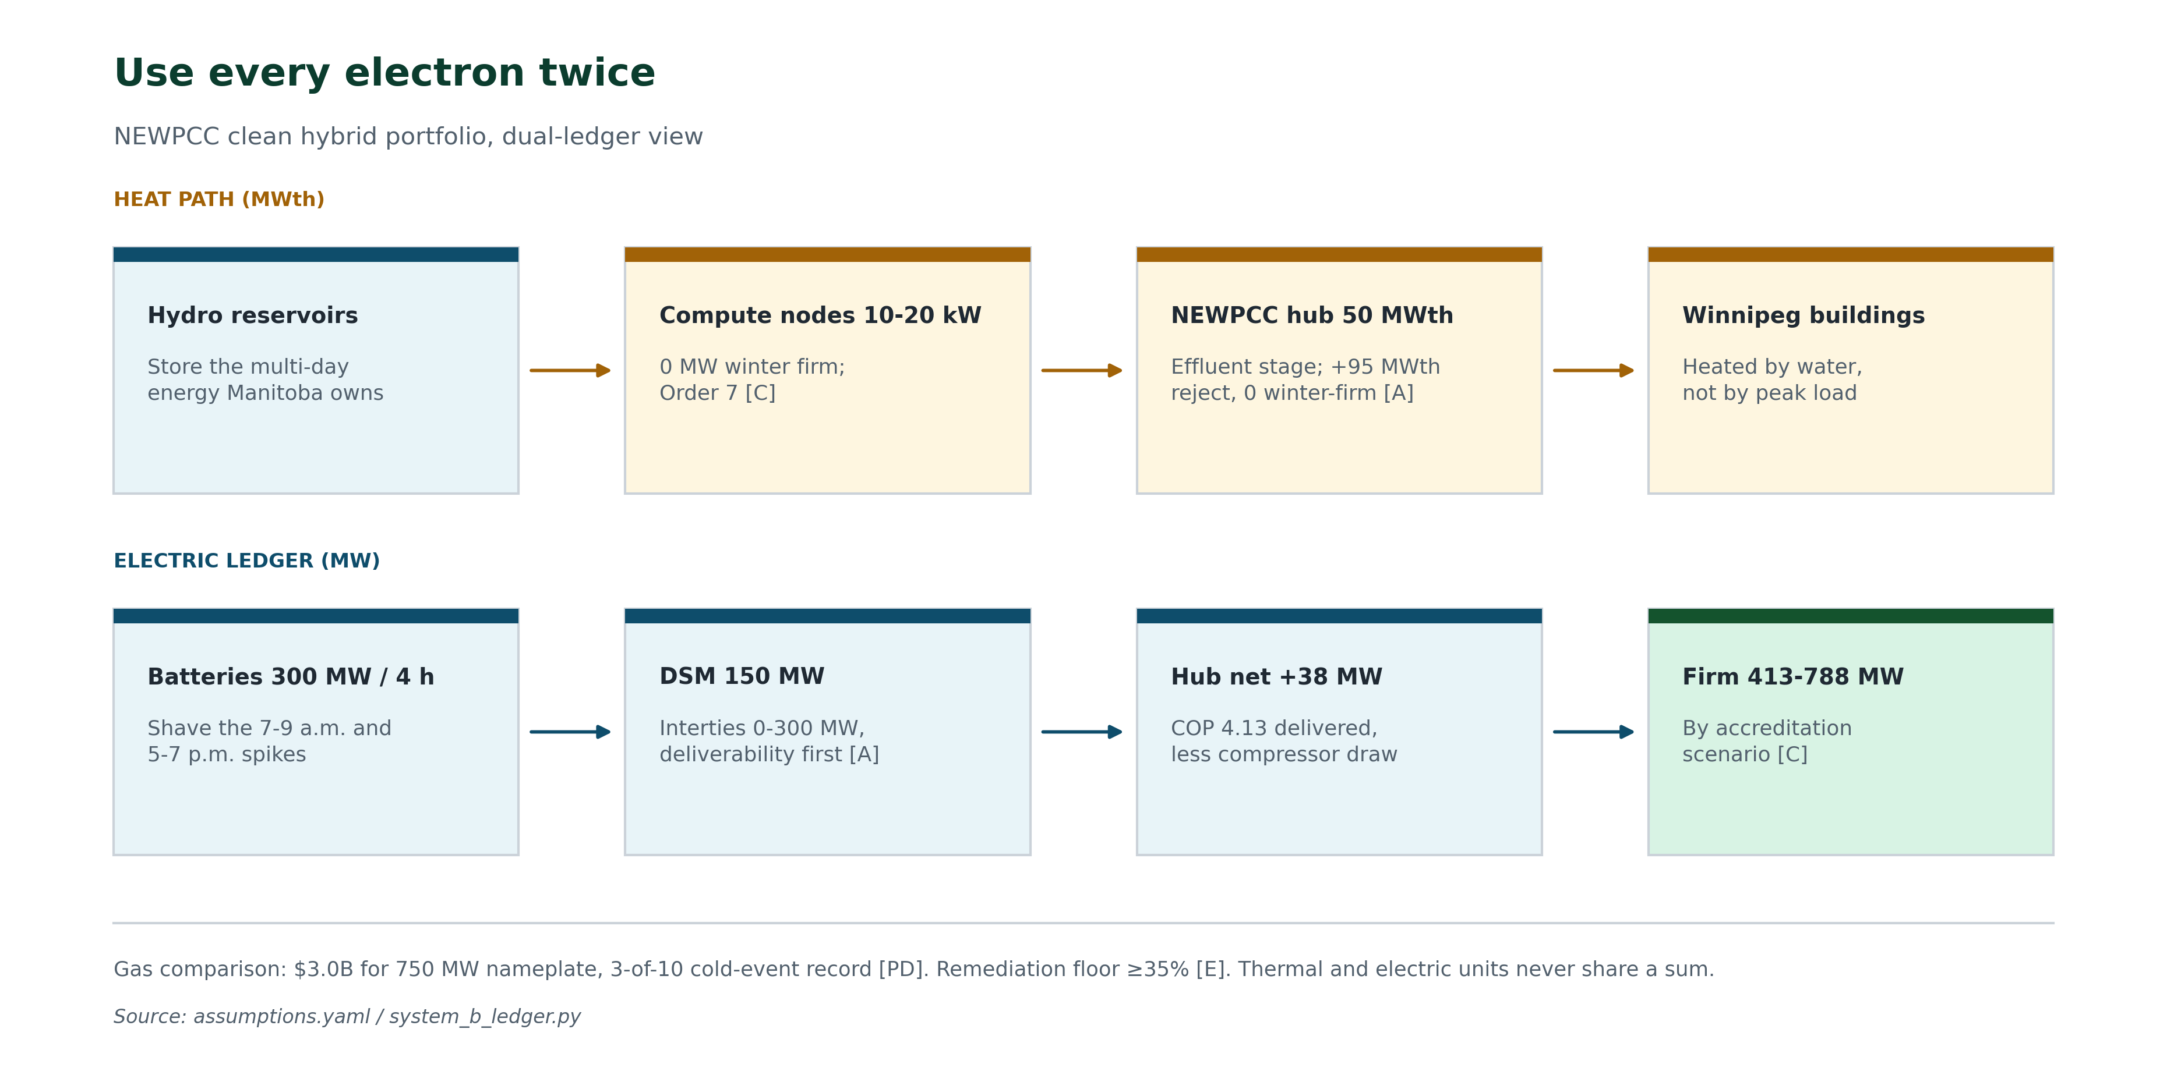
Figure 3 — Five pieces: electric ledger and heat path on the same numeric scale; heat is never added [C/E].
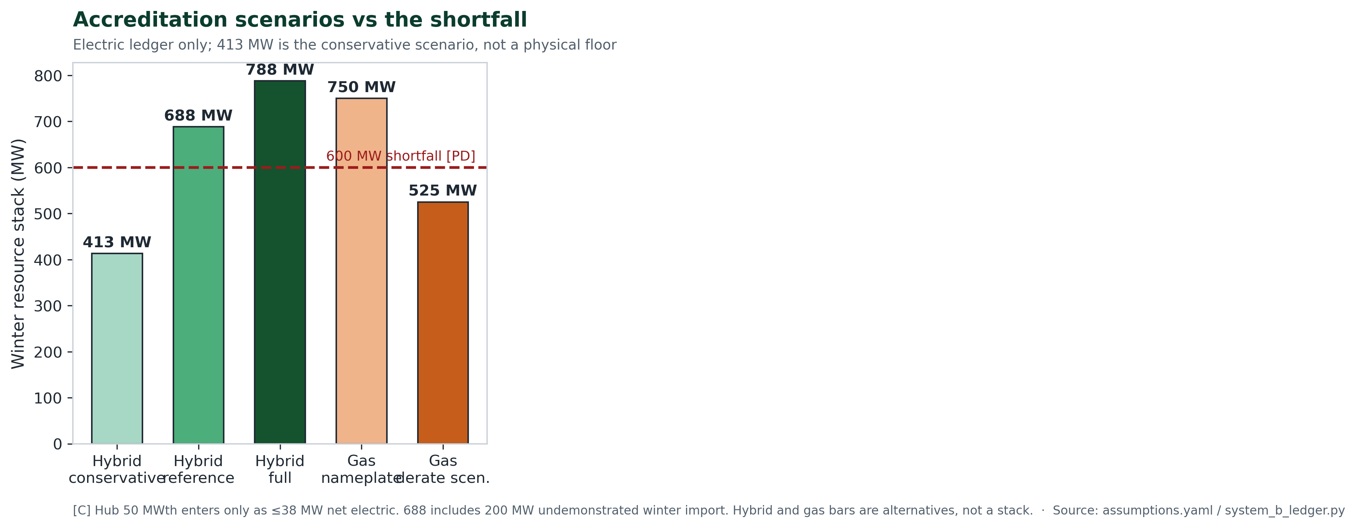
Figure 4 — Planning cases vs the 600 MW shortfall. Electric ledger only [C].
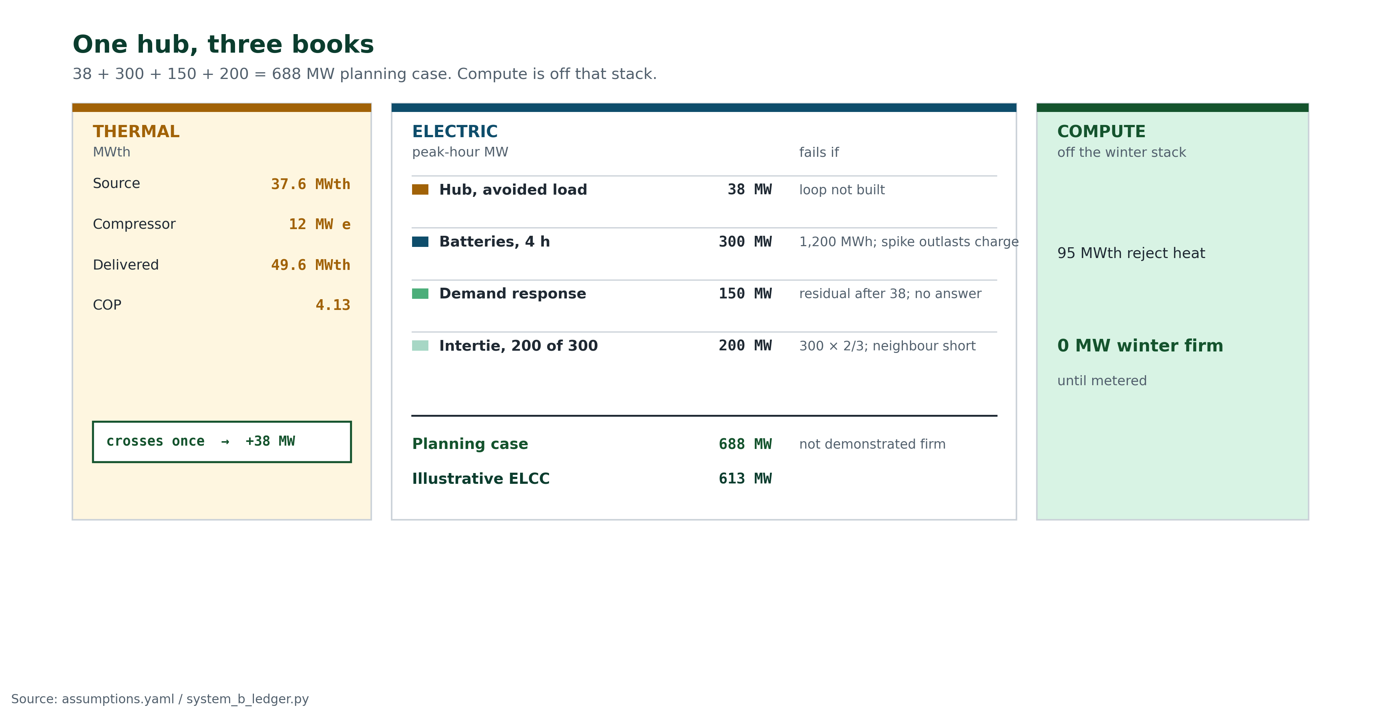
Figure 5 — Three books: effluent and compute on the thermal ledger, 688 MW planning stack, compute still 0 MW electric [C].
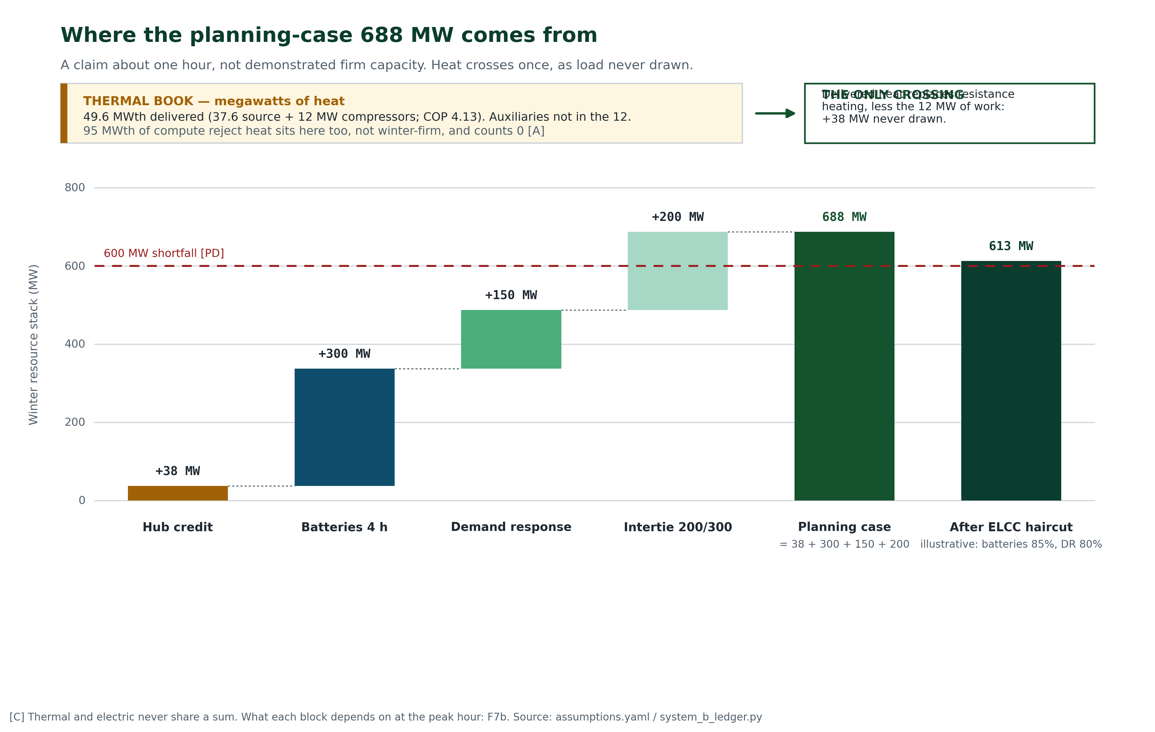
Figure 6 — How the dual ledger works: the 50 MWth effluent stage credits +38 MW electric net; compute reject stays gated; winter firm is 413 / 688 / 788 MW [C].
Conservative (413 MW) is the conservative scenario — interties at zero, DSM at half — so the Board can see what fails if optimism is stripped out. It is not a physical reliability floor. Planning (688 MW) bridges 600 MW on nameplate arithmetic by +88 MW — a margin that requires 150 MW of unfilled demand response and 200 MW of intertie convention [A]. Without that import credit the stack is 488 MW, which does not bridge 600. Conservative 413 MW does not. Full (788 MW) widens the nameplate margin by +188 MW. Under an illustrative accreditation sensitivity (BESS at 85%, DSM at 80%), planning still clears at 613 MW. That is not an ELCC study. Modular batteries and demand response can close gaps without pouring a single-station foundation.
Winter proof file. Heat 38 MW: 50 × coincidence − 12; January extract and coincidence still open; hub-off is 375. Batteries 300 MW: 1,200 MWh identity; Hydro must show charging power between successive critical days. Prospective DR 150 MW: residual after 38, incremental to Hydro’s 310, inventory unfilled. Intertie 200 MW: 300 × 2/3; fail-closed 488; next hydro is sequenced, not stacked. Accreditation 613: illustrative; chronological ELCC is Order 1 — the same hourly drought model for gas, the bridge, and bridge-then-hydro, without adding Conawapa megawatts to 413 / 688 / 788.
Order 1 tape. Dated hours, observed vs counterfactual. 7 January 2022, 20 December 2022, 22 January 2023, 23 January 2023: Brandon derated [PD]; peak MW open. 20 January 2025: 5,111.5 MW at −32.7 °C; Brandon derating open. Hub 0 — not built. Batteries 300 MW capability, not applied. DR open. Intertie 0 on this tape. Recall open. Capability is not dispatch.
4. Winter modelling: planning stack +88 MW; illustrative accreditation +13 MW
Manitoba is winter-peaking: load climbs as the thermometer falls, and it peaks hardest on the coldest days. An unmanaged heat-pump rollout only steepens that curve. The hybrid model flattens it, by moving heat off the electric peak and covering the two daily spikes. The 2024–2035 peak-path exhibit is in the mathematical appendix.
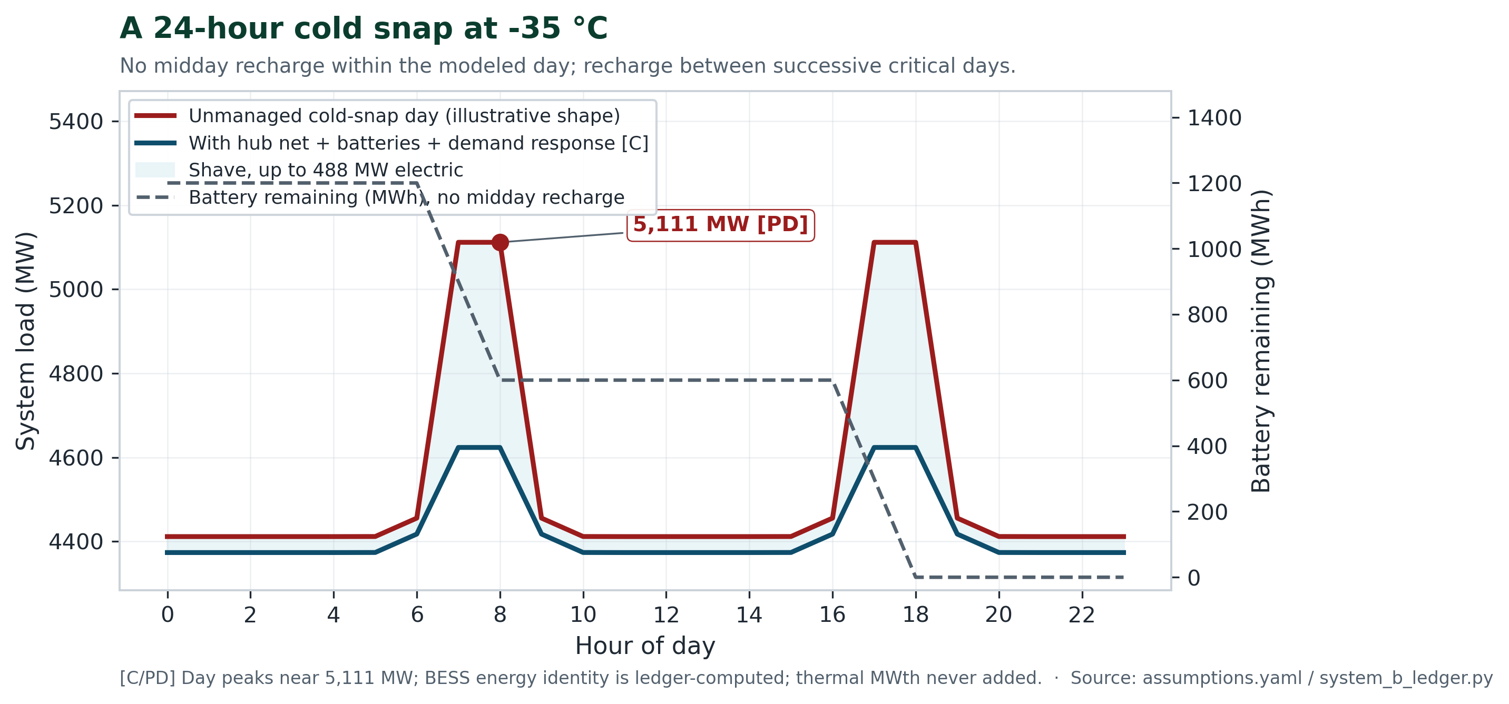
Figure 7 — Winter operating day in megawatts — not a cost chart. Hub net all day; batteries cover two 2-hour spikes [C/PD].
Claimed: planning bridges 600 on nameplate arithmetic if DR and the 200 MW import show; 413 MW and 488 MW do not. Not claimed: summer cooling megawatts as winter firm; flat 30% gas derate as proven ELCC; “>98%” hybrid availability.
5. Money: $1.5–1.8B net of ITC vs $4.5–6.9B
Hydro’s planning assumption for Brandon gas capital is about $3.0B. That figure is still being refined. The hybrid’s overnight capital is $1.95B gross, or $1.50B if the federal Clean Technology ITC is confirmed [A]. We show both because credits are assumed, not fact. The $1.95B is $0.60B batteries, $0.50B network, $0.45B hub, and $0.40B demand response [E]:
$0.60B + $0.50B + $0.45B + $0.40B = $1.95B.
The hub is plant and piping. The network is the district loop. Both are planning allowances for connecting buildings and for work in the municipal right-of-way. This total does not include Conawapa. It does not include buying the 200 MW winter import in the planning case. There is no firm contract in this file that would make a 200 MW winter purchase unnecessary. Until Order 1 confirms delivery, those 200 MW remain an uncosted assumption.
Overnight dollars per kilowatt are capital divided by megawatts:
$3.0B ÷ 750 MW = $4,000/kW.
$1.95B ÷ 688 MW = $2,834/kW.
$1.50B ÷ 688 MW = $2,180/kW.
That is about 1.4 times cheaper on the gross capital.
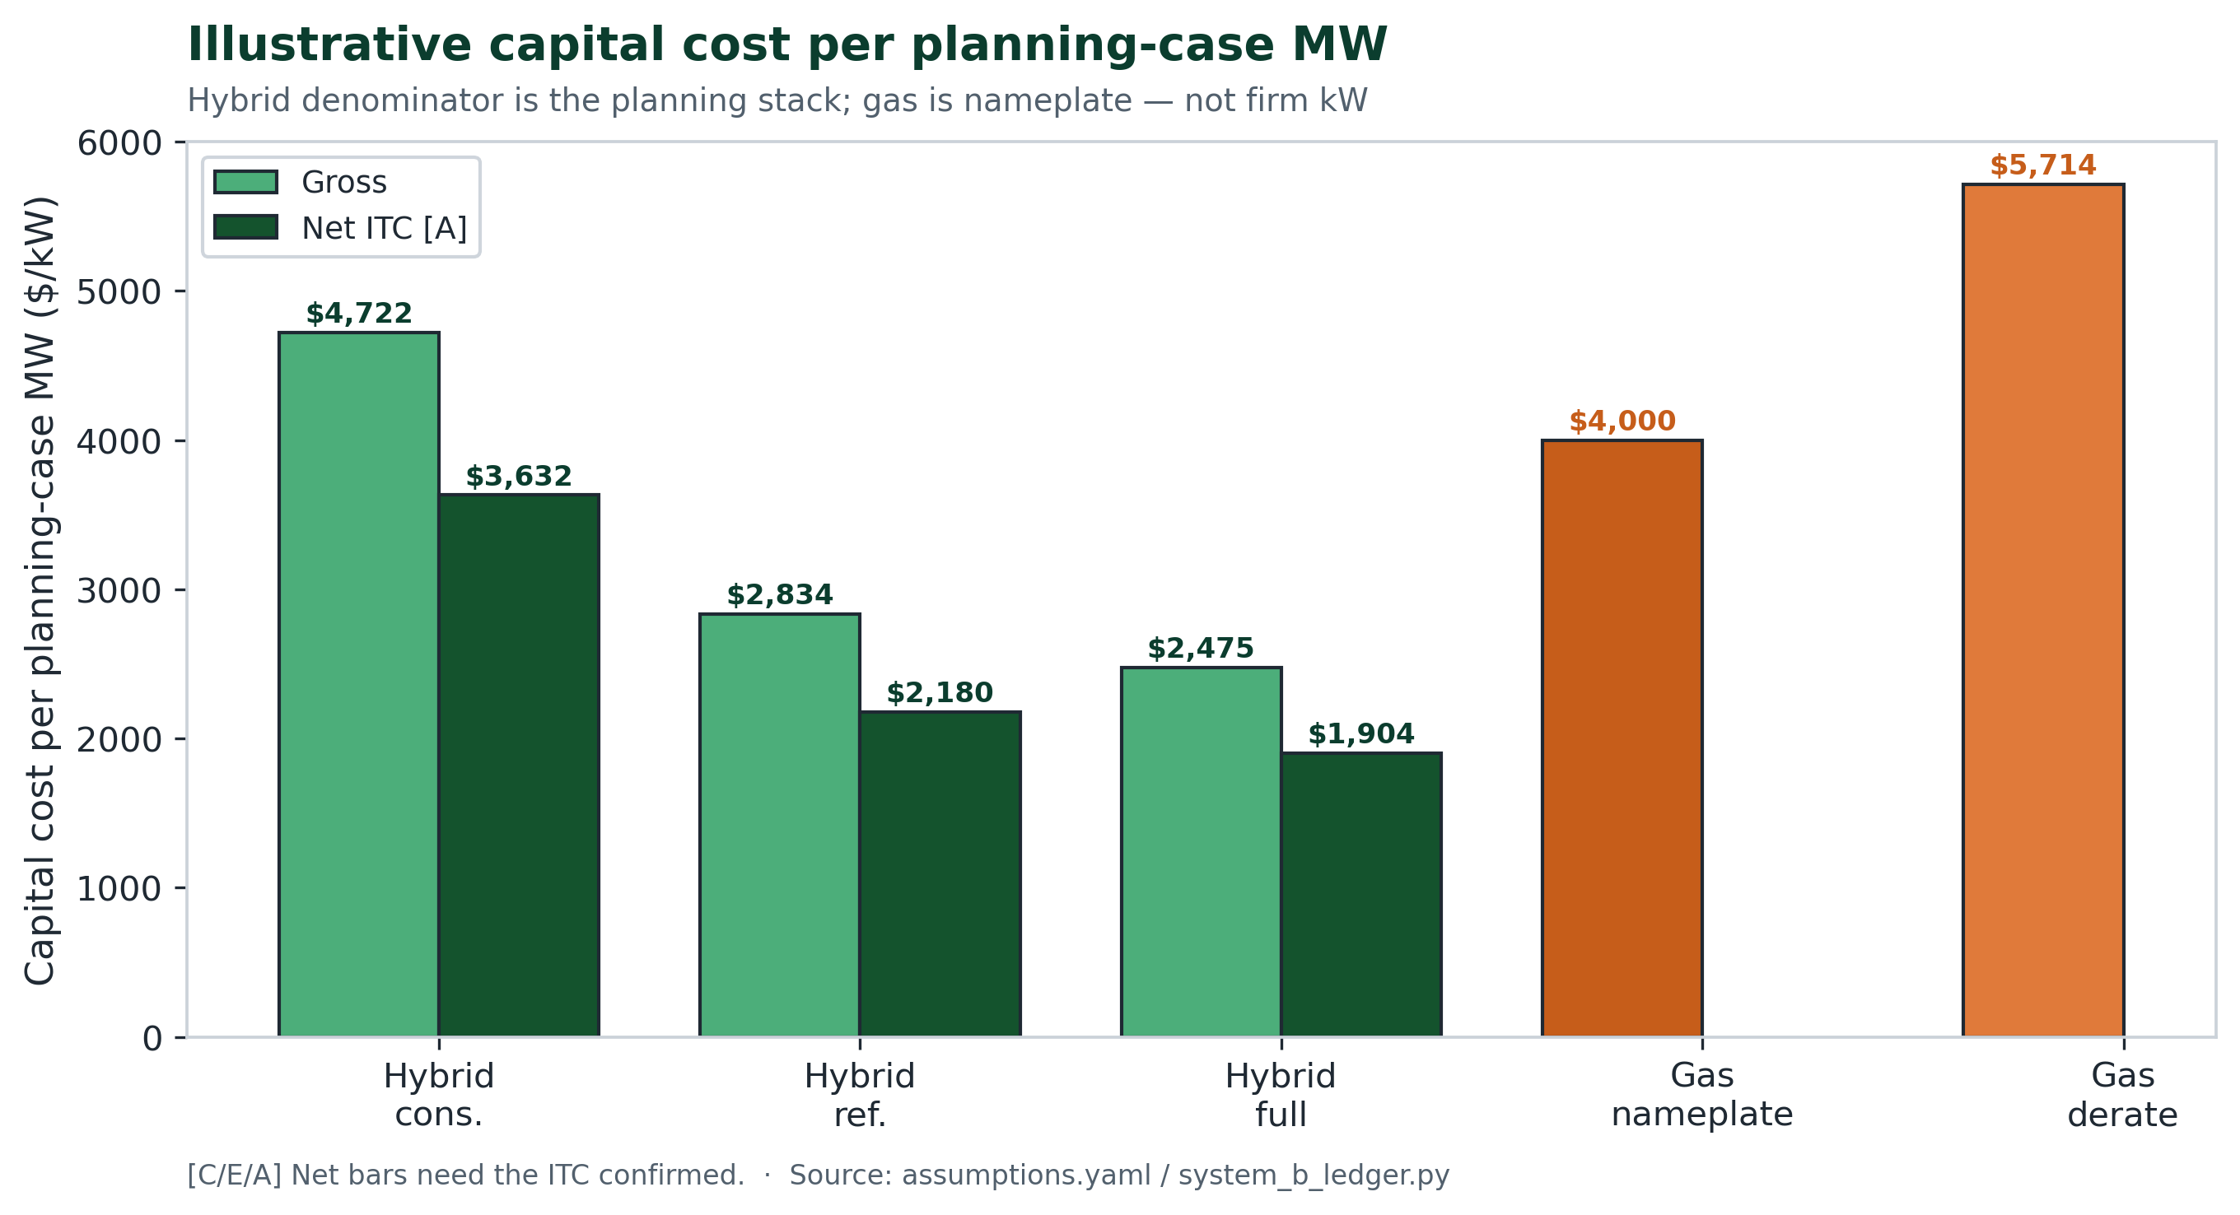
Figure 8 — Overnight capital divided by megawatts ($/kW). $3.0B ÷ 750 MW = $4,000/kW gas nameplate. $1.95B ÷ 688 MW = $2,834/kW gross; $1.50B ÷ 688 MW = $2,180/kW net of ITC. [C/E/A].
Overnight capital is not the bill. Fuel, carbon, and twenty years of running the plant are. Those all-in bands do not overlap: gas $4.5–6.9B, hybrid $1.5–1.8B net of ITC ($1.95–2.25B without). The hybrid bands are domestic capital only. They do not include a twenty-year import bill.
$4.5B − $1.8B = $2.7B. $6.9B − $1.5B = $5.4B.
Under these modelled bands, the cheapest defensible gas future still costs $2.7B more than the most expensive defensible hybrid future. That gap is why the twenty-year bands decide the case, not a single dollars-per-kilowatt ratio.
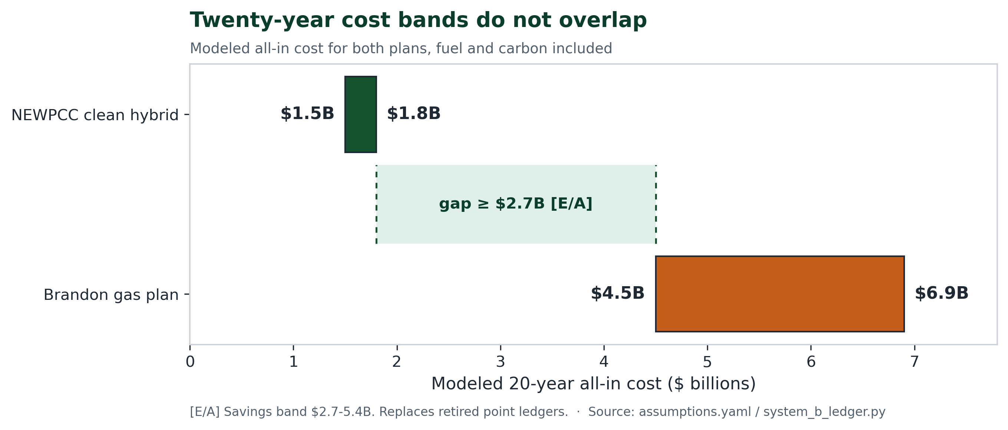
Figure 9 — Twenty-year all-in cost in billions — fuel and carbon included. Gas $4.5–6.9B; hybrid $1.5–1.8B net of ITC. $4.5B − $1.8B = $2.7B; $6.9B − $1.5B = $5.4B [E/A].
Funding agreements cover the first two projects; however, Project 3 has no funding agreement [PD]. Who will own the pipes, and who will connect neighbourhoods, is still open. There is no public construction schedule that extends to summer 2030.
For ratepayers
Three billion dollars of rate-based fossil capital, plus fuel and carbon, shows up on bills. A smaller, fuel-free package — and a North End heat utility that can attract clean-energy capital a compliance sewage plant alone cannot — shows up more gently. Heat taps missed at NEWPCC are wasted for a generation.
All numbers at a glance
Quantity | Value | Role
2024 winter peak | 5,111.5 MW | Exam anchor [PD]
2030 firm shortfall | 600 MW | Hydro disclosure [PD]
Gas capital / nameplate | $3.0B / 750 MW | Brandon referral [PD]
Gas derate scenario | 525 MW | Event-informed [A] — not ELCC
Hybrid capital | $1.95B / $1.50B net | Net needs ITC [A]
Winter firm electric | 413 / 688 / 788 MW | Cons / ref / full [C]
Margins vs shortfall | −187 / +88 / +188 MW | Only planning bridges
Hub, effluent stage | 50 MWth → +38 MW | Dual ledger [C]
Hub, compute reject | 95 MWth contingent | Gated; load netted first — 0 credit [A]
$/kW reference | $2,834 / $2,180 | 688 MW planning; 488 MW ≈ gas $4,000 nameplate
20-year all-in | $4.5–6.9B vs $1.5–1.8B net of ITC | Savings $2.7–5.4B ($2.3–5.0B gross basis)
PDRC summer | 180 MW heat → ≈50 MW | Seasonal book — not winter firm [E]
BTES chiller avoid | 70 MW | Seasonal book — not winter firm [E]
Summer total | ≈120 MW | 50 + 70; do not add to GroundPeak 120
6. Audit: compare both plans, assert neither
The 3-of-10 cold-event record is grounds to commission an independent ELCC study — not to assert a flat 30% derate as proven fact, and not to treat “near-perfect reliability” as settled. Hydro’s 91% start-reliability figure answers a different question: annual averages blend mild months into the average peak planning must ignore. The Board’s concern is conditional availability in the top load hours.
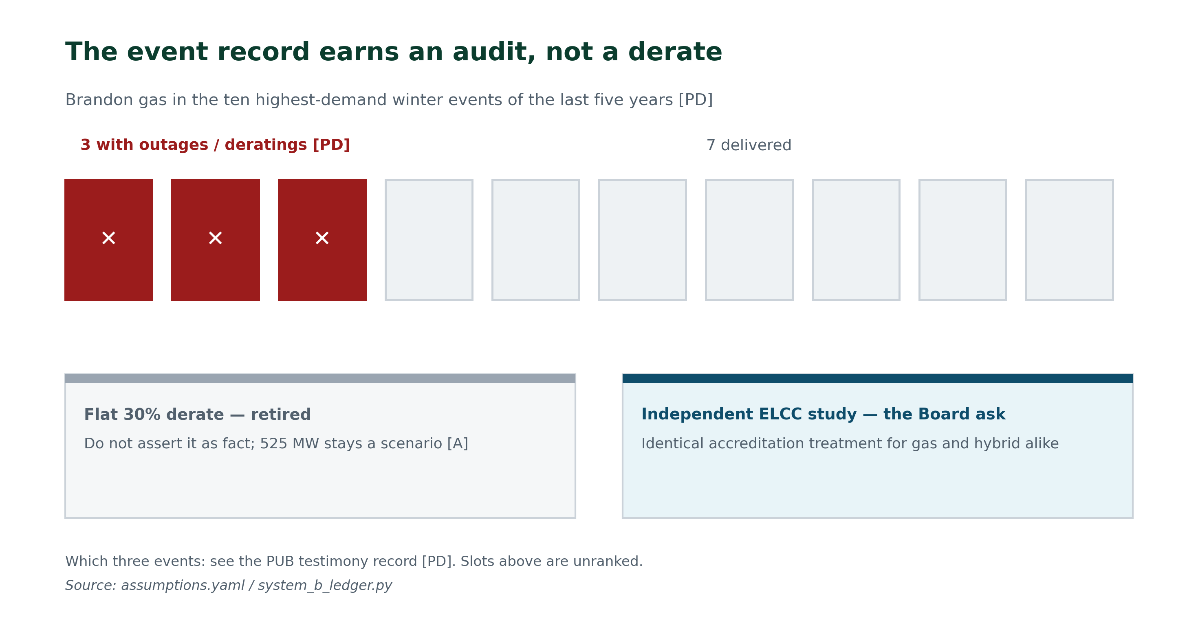
Figure 10 — Event record → Board audit ask. 525 MW is a scenario only [PD].
Against the multi-day vortex objection: reservoirs supply the days; batteries and demand response supply the hours; district heat and dual-fuel shrink the need itself. A four-technology, multi-site portfolio has no single component whose loss removes most of its capability. A single station on a single fuel line does.
7. The ask: seven orders before the concrete pours
The Board need not adopt our numbers — only insist that both plans face the same arithmetic in public. Orders 1–4 put both plans under the same exam. Orders 5–7 keep the alternative open while that exam runs: preserve the trench, meter a heat pilot, and authorize public heat-first compute.
- Head-to-head hybrid (incl. sewage heat) vs gas — LOLE / ELCC / $/kW-year — before any capital certificate, including whether a 2030 peaker still leaves Hydro’s next northern station off the path.
- Independent cold-weather audit at ≤ −30 °C; identical ELCC rules for both plans.
- Machine-readable cost models from both parties.
- Disclose interconnection headroom near screened anchors + extreme-event logs.
- Preserve NEWPCC trench / effluent heat-recovery option while contracts are open.
- Measured heat pilot: effluent-stage hub at NEWPCC, with public metered filings.
- Authorize public heat-first compute: locked 10–20 kW per-site band, publicly accountable, heat recovery required, public metered filings — not contingent on pre-cleared gates.
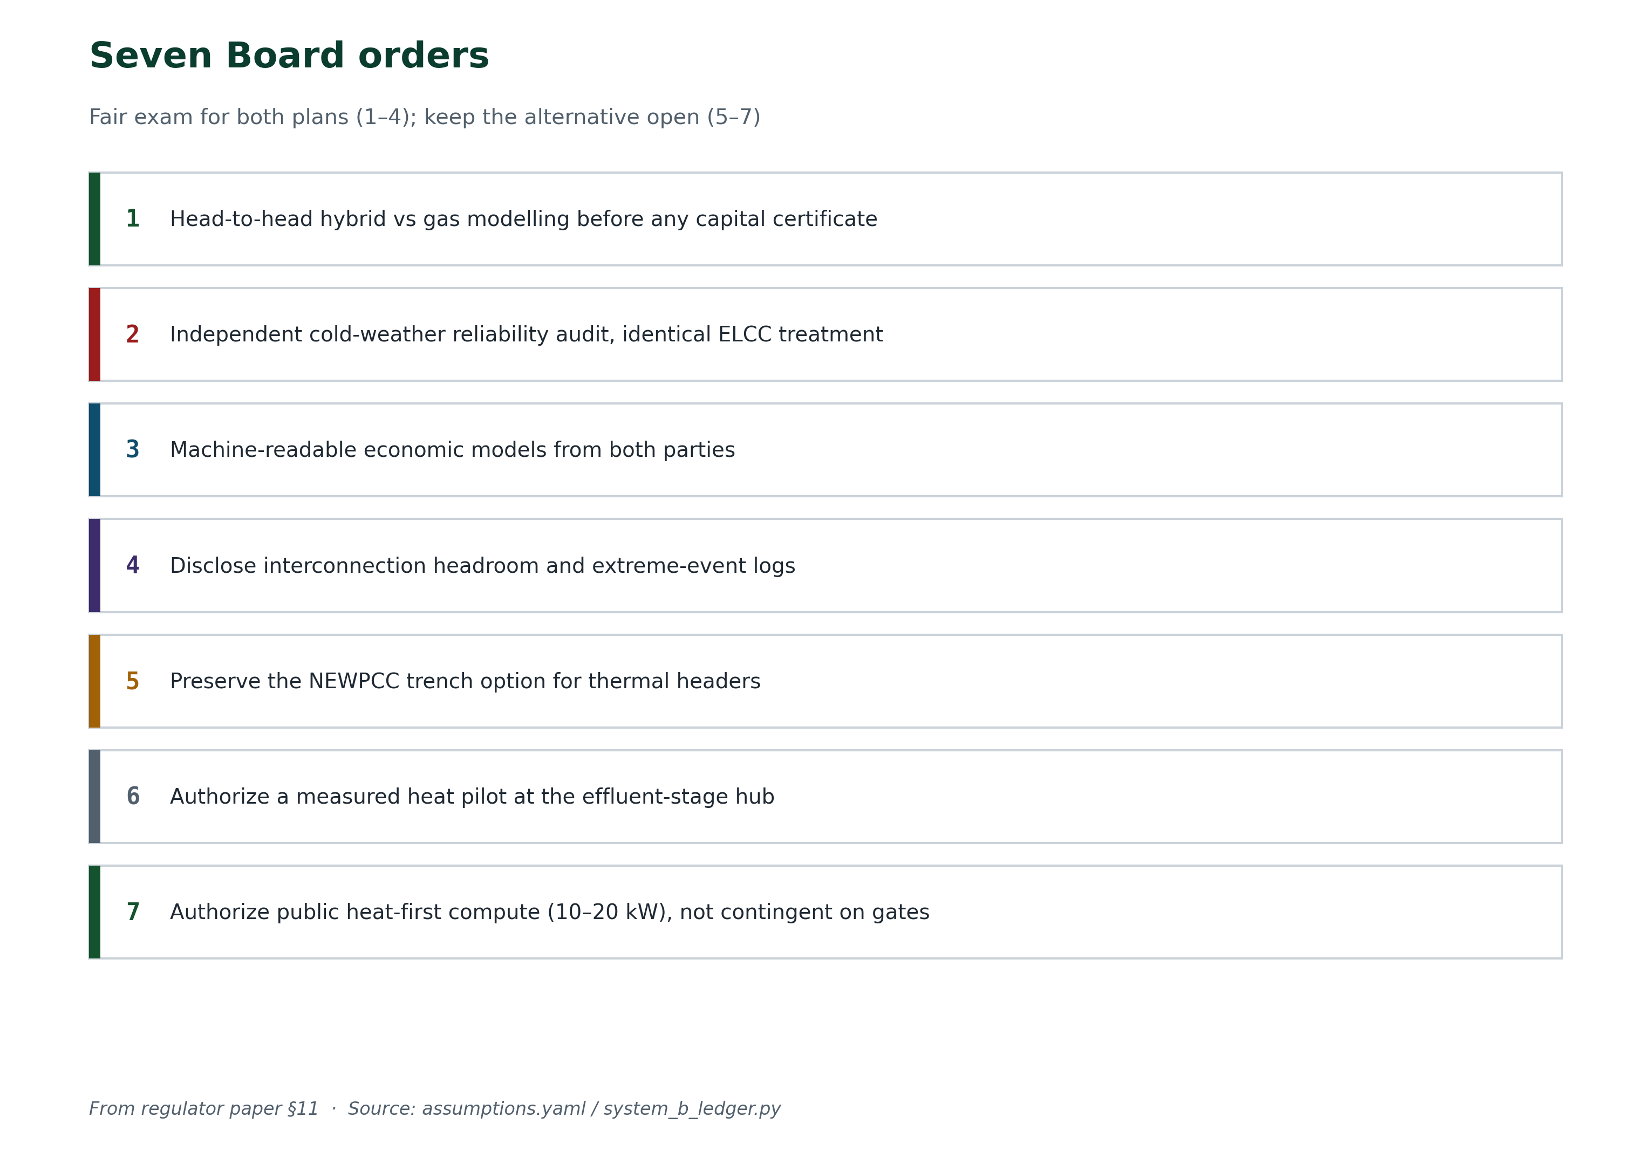
Seven orders. Test both plans; keep the trench, the taps, and a public trial.
8. What would change our mind
A case that cannot say what would overturn it is advocacy.
- An ELCC finding gas tail-hour availability above ~95% and battery accreditation far below its four-hour rating.
- Verified capital quotes pushing the portfolio far above $1.95B gross, or gas far below $3.0B.
- A twenty-year gas scenario under $4.5B under filed fuel and carbon curves.
- District-heat uptake stuck at effluent-only — already priced in the 413 MW case.
- If the bridge cannot cover the drought-year hour, gas stays on the table. Conawapa does not excuse that.
None of these falsifiers has occurred. Each is checkable. Symmetric candour has not, to date, been offered for the gas plan.
9. Beyond winter: public compute, summer PDRC, and a ground battery
Public compute, PDRC films, and a ground battery complement the hybrid. They are not contingent on it. The winter stack still has to stand on sewage heat, batteries, demand response, and the ties. These ideas add the rest of the year: a heat customer that can shed, roofs that dump heat to the sky, and a ground battery that banks cool until January. They do not add a watt to 413 / 688 / 788. They do not close the 13 MW illustrative accreditation margin. Each stays on its own book until it is metered.
The third book: public compute
Public compute is a theoretical add-on. It could aid heat, and it could aid revenue. Small 10–20 kW heat-first nodes would buy heat into the loop and pay for power on hours that are not the peak. Order 7 asks the Board to let a public trial prove three rules: they shed at peak, heat recovery comes first, and the meter is public. They still add 0 MW to the winter firm ledger [C]. If that model grows, the same loop could reject up to 95 MWth. That is later-scale thermal upside, not a seventh block in 688 MW.
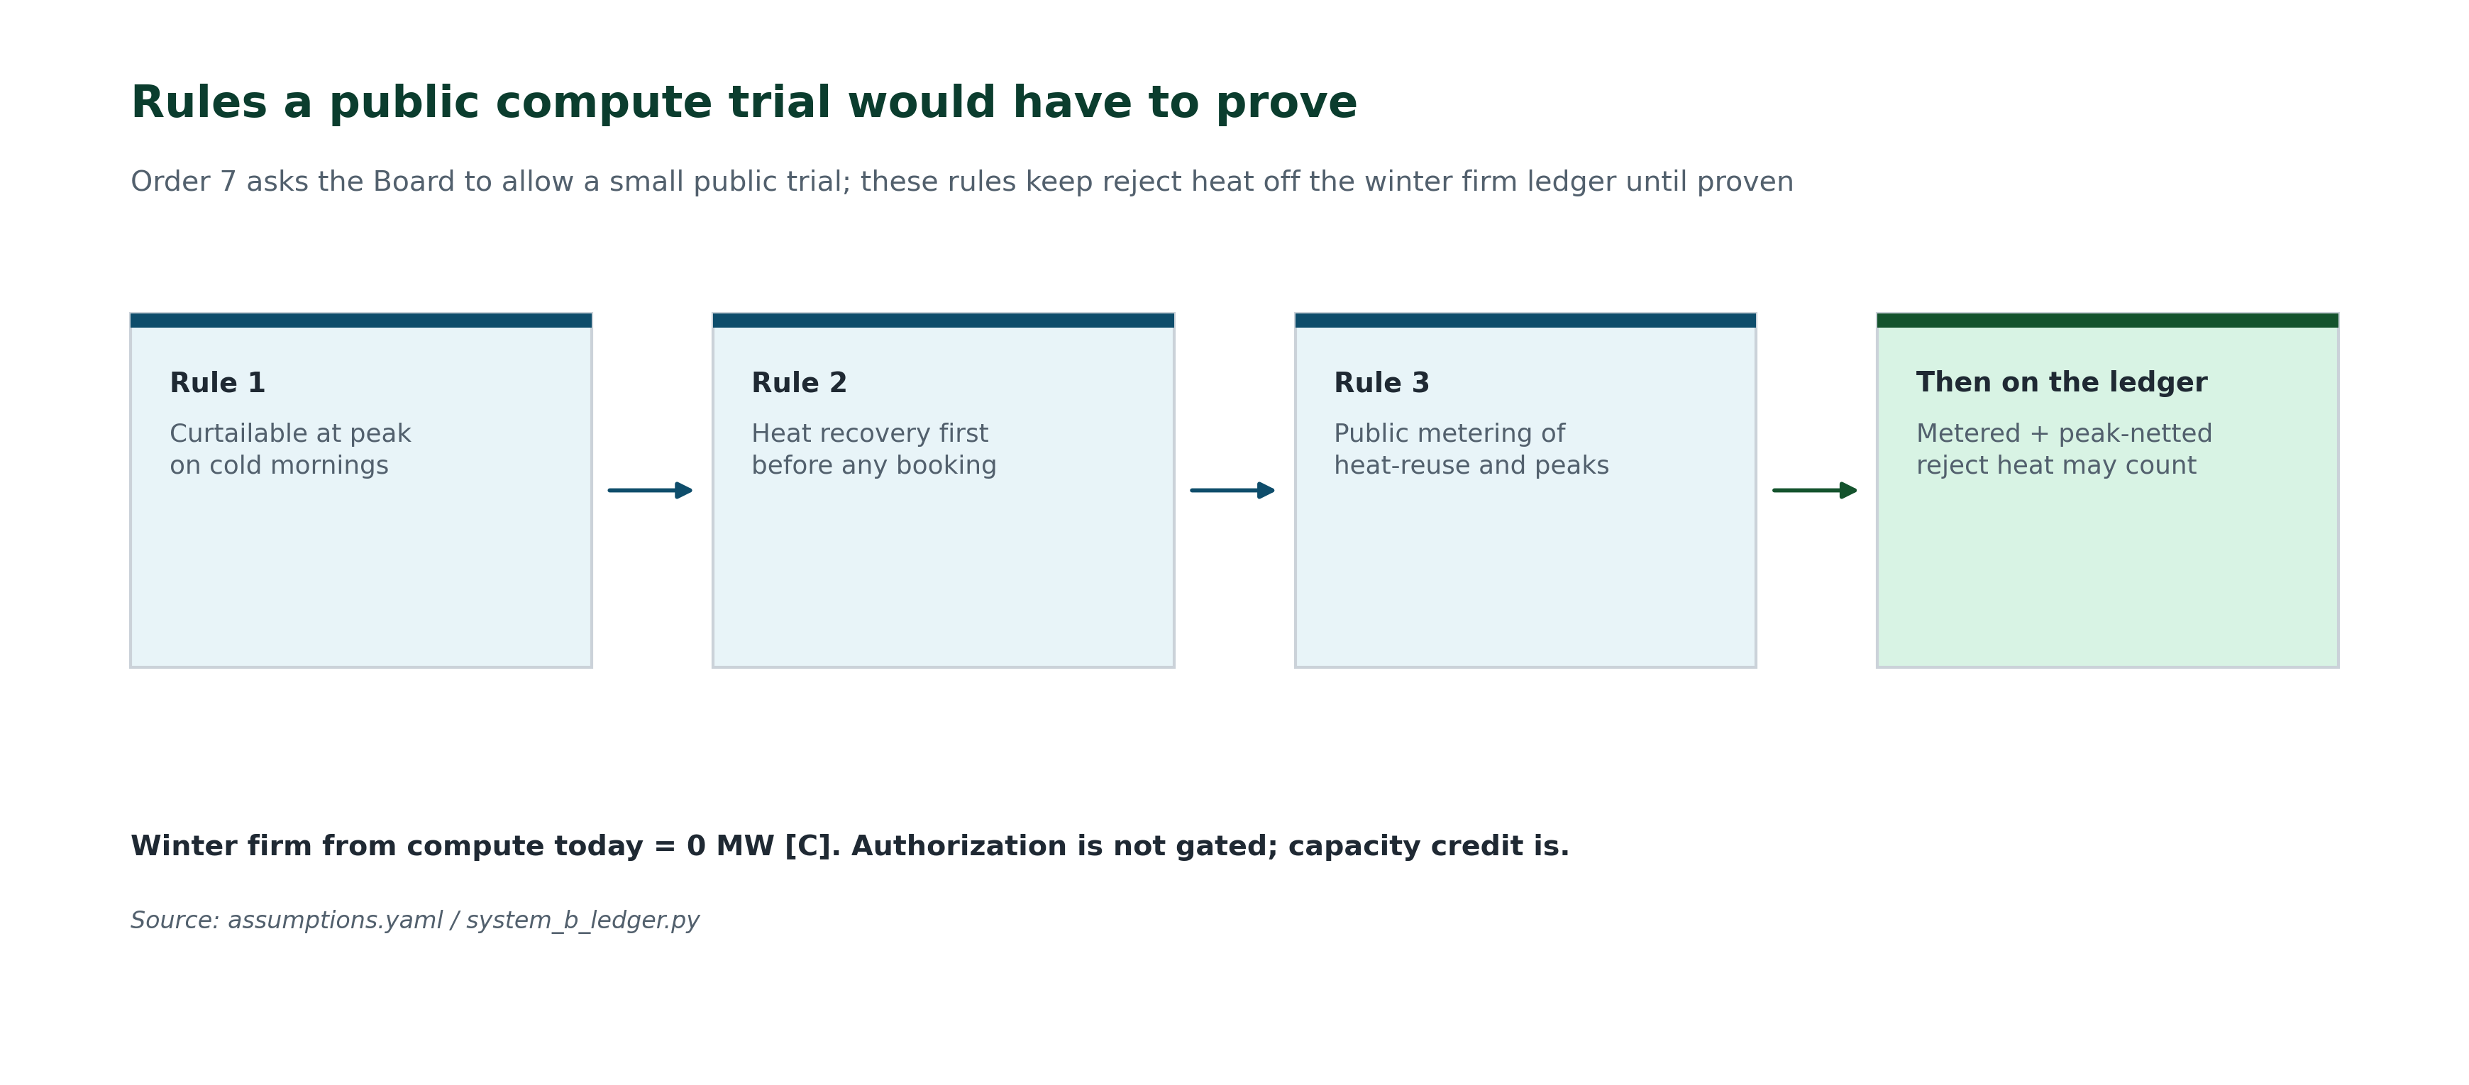
Figure 11 — Rules a public trial would have to prove: peak curtailment, heat-first use, and public metering — reject heat stays off the winter firm ledger at 0 MW until proven [C].
Summer book: PDRC and a ground battery
In Manitoba, heating is the biggest issue during winter, and cooling is the main challenge in summer. Solving both problems needs a mix of solutions, not just one technology.
Passive daytime radiative cooling (PDRC) films on large commercial and institutional roofs help release heat into the sky. 2.4 million square metres of roof at about 75 W per square metre can remove about 180 MW of heat. That is 240 hectares of roof — a little under a square mile. With a chiller COP of 3.5, that saves around 50 MW of electricity that would otherwise be used for air conditioning at +35 °C [E]. The films work best during peak sunlight. They do nothing at −35 °C.
A ground battery — borehole thermal energy storage (BTES) — stores heat underground. In summer it lowers the chiller load by about 70 MW [E]. In winter it can provide stored heat to buildings. The planned discharge is 120 MW coincident for GroundPeak islands, P7, in 2035, gated G6/G7 [E]. Eligible on the winter firm ledger today is 0 MW [C], the same pattern as public compute. That 120 MW is not the summer 50 + 70; the numbers match by coincidence and should not be added together. Neither number enters 413, 688, or 788.
In summer, the combined 50 MW and 70 MW give 120 MW of relief during heatwaves, against a usual summer peak of 3,800 to 4,200 MW and a heatwave anchor of 3,514 MW [E]. That is a separate seasonal benefit. It does not solve the 600 MW winter shortfall. These steps do not help with winter power supply. They are not winter firm.
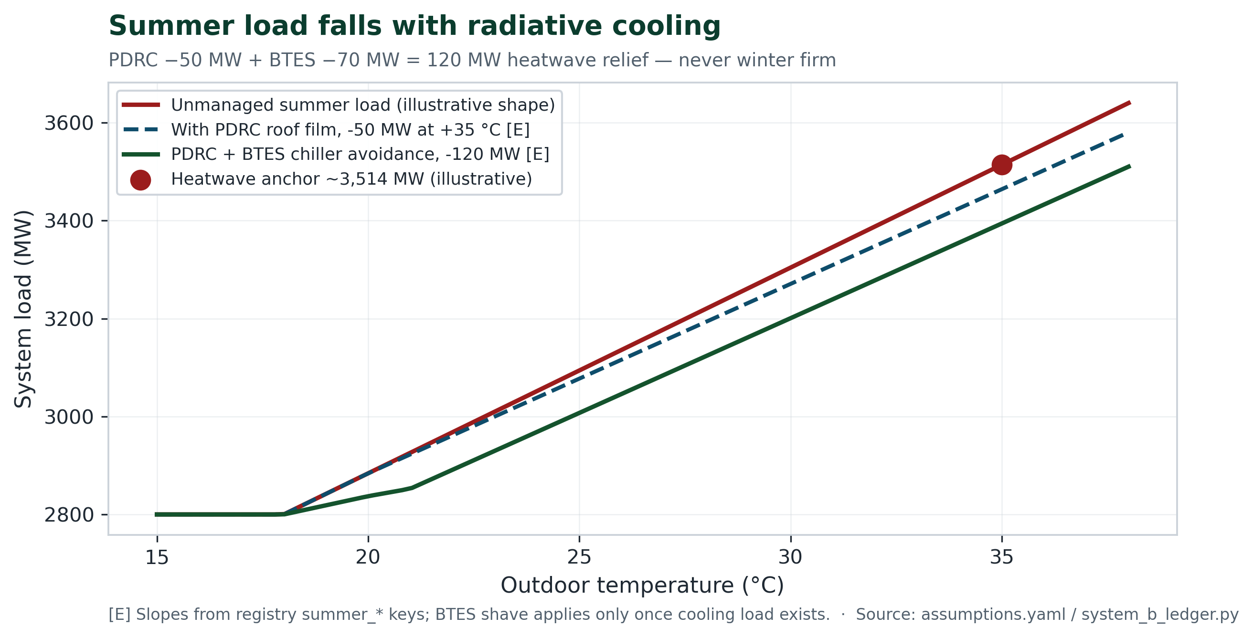
Figure 12 — Summer load vs temperature: PDRC on roofs and the ground battery lower the heatwave curve [E].
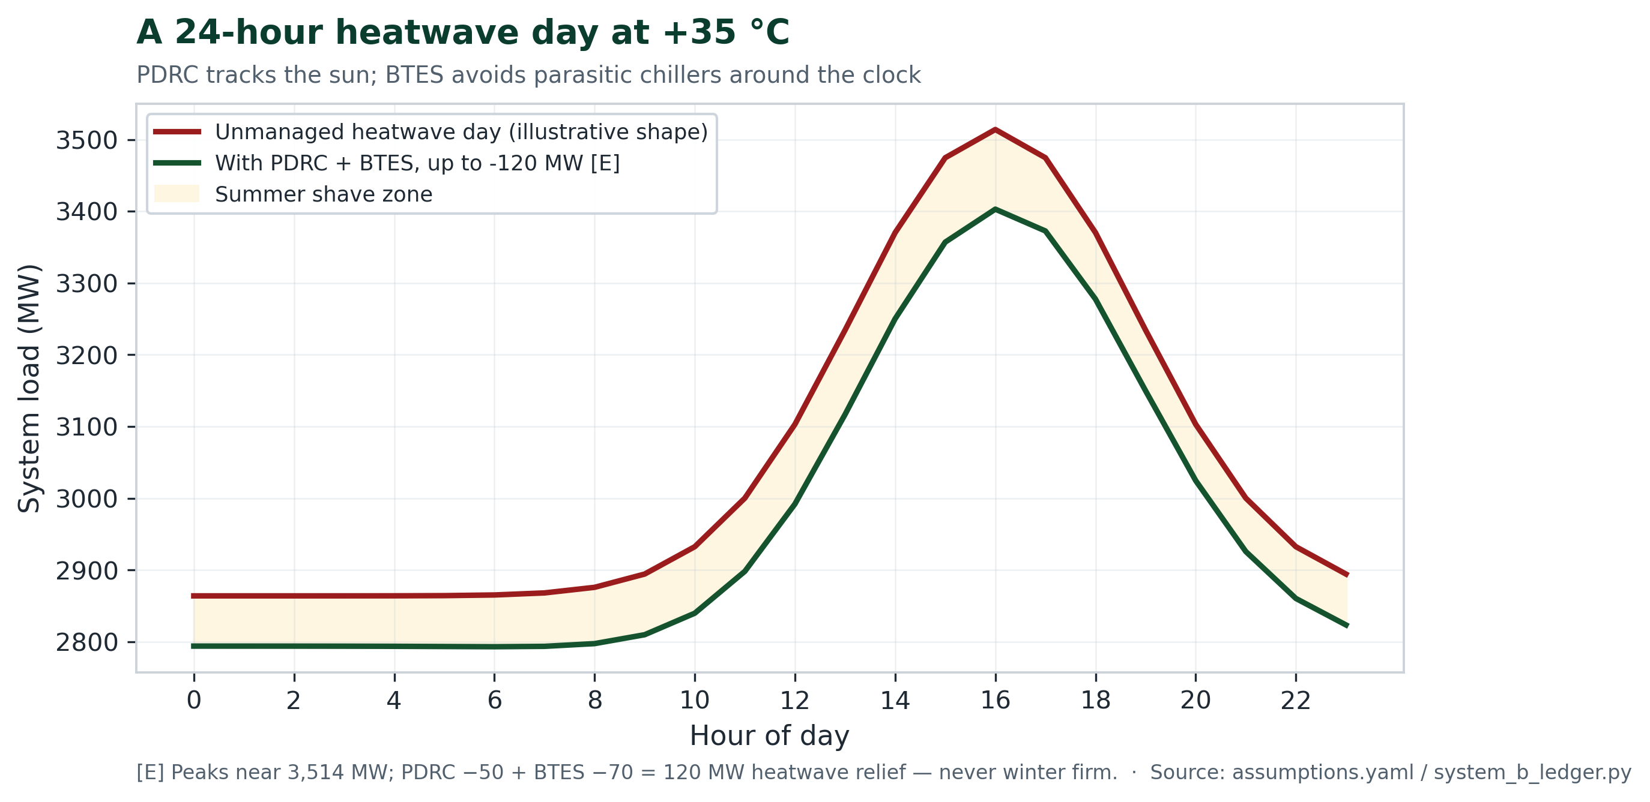
Figure 13 — A 24-hour heatwave day: PDRC tracks the sun; the ground battery works around the clock [E].
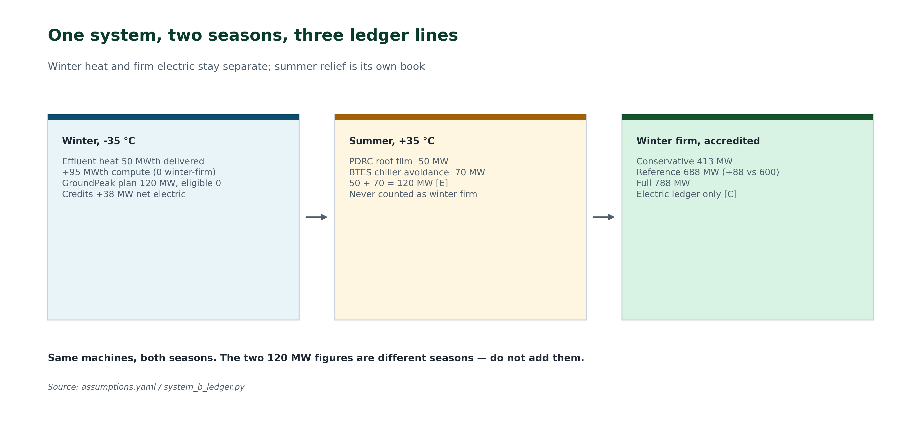
Figure 14 — One system, two seasons, three ledger lines; only the electric ledger decides the winter case [C/E].
Summer equations are in the mathematical appendix.
Clean power is not a discount coupon for big tech
Manitoba was right when Premier Wab Kinew rejected a hyperscale AI campus southeast of Winnipeg. The concern was not “technology.” It was scale, electricity use, community impact, and whether benefits last for Manitobans. Recent reporting also noted he did not reject data centres altogether — he distinguished ordinary and future facilities from hyperscale projects of a much larger order.
Saying no to one giant private extraction machine should not mean saying no to digital infrastructure. The cloud is not an idea. It is buildings, wires, substations, cooling, water, workers, land, and electricity. Health care, schools, emergency systems, research, city services, and climate modelling all need a physical place to run. The real question is whether private corporations should control almost all of those places — or whether the public should own some of them too.
Manitoba has a unique advantage. The Canada Energy Regulator reports Manitoba produced 33.3 TWh of electricity in 2023, with 99.7% from renewable sources, mostly hydro [O]. That clean power is not a coupon to hand to distant shareholders. It is something Manitobans built and passed down. If it is going to serve the digital economy, Manitobans deserve public ownership, accountability, and real public benefits — not only construction traffic and unclear promises about innovation.
A Manitoba tradition — when something becomes essential, ask who owns it
We have taken this approach before:
None of those projects were perfect. Mistakes were made. That history should make us more careful, not less ambitious.
A data centre is power, heat, water, communications, and — increasingly — public-service infrastructure. Spirited Energy treats small, publicly accountable compute as climate infrastructure: heat-first into the NEWPCC district loop, locked at 10–20 kW per node, 0 MW eligible until heat customer, Hydro headroom, and public buyer are verified [C]. That is the opposite of a hyperscale warehouse on farmland. It is the Manitoba rule applied to the cloud: when something becomes essential to daily life, ask whether the public should own a share.
What we are not proposing
Not Île-des-Chênes-scale private load. Not handing hydro to big tech as a discount. Not counting speculative compute megawatts as winter firm capacity. Effluent heat is the base; public compute is theoretical upside behind a public trial — and today the verified eligible number is zero.
10. What this system actually does
Manitoba Hydro does not need more electricity in every hour. It needs more capacity during a relatively small number of difficult hours — especially on very cold winter mornings.
Manitoba is a winter-peaking system. Hydro says electricity use can be as much as 65 per cent higher in winter than in summer [O]. Historically, many of Hydro’s export customers have peaked in summer, when air-conditioning demand is high. That seasonal difference creates opportunities for Manitoba to sell surplus power south.
But we should not overstate that advantage. MISO is also becoming more winter-peaking as electric heating and other loads grow. On some future winter mornings, Manitoba and its neighbours may both be under pressure.
That is where the hybrid system helps. It does not create new hydroelectric generation. It reduces and shifts Winnipeg’s demand so that Hydro has more room to operate. Depending on water conditions, transmission limits, contracts and market prices, Hydro could use that room to preserve reservoir water, avoid imports, reduce gas generation, maintain reserves or export more power. The system creates flexibility; it does not guarantee an export.
In winter, the wastewater-heat network would supply buildings with heat while using much less electricity than resistance heating. If the proposed hub produces a verified net reduction of 38 MW during Hydro’s winter peak, it gives the system 38 MW of peak relief [C]. That figure must subtract the electricity used by heat pumps, pumps and controls, and it counts only while the network and its connected customers are available.
Batteries handle shorter peaks. A battery rated at 300 MW for two hours can deliver 600 MWh in one event. Covering two such events without recharging would require 1,200 MWh. It cannot be counted as 300 MW available all day. Demand response can provide additional relief, but only for loads that are enrolled, tested and actually respond when called.
In summer, radiative roofs and thermal storage reduce air-conditioning demand. The current model assigns approximately 50 MW to roof cooling and 70 MW to the ground-storage system on a typical July afternoon [E]. Those are summer operating assumptions — not proven heatwave capacity, and not winter firm supply.
A control platform coordinates the pieces. Using weather forecasts, building demand, storage levels, electricity prices and system constraints, it can preheat or pre-cool buildings, charge storage during lower-value hours, discharge it during peaks and briefly defer loads that can wait. Automation does not create energy. It makes existing energy and storage available at more useful times.
The emissions case also needs careful accounting. Manitoba electricity is exceptionally low-carbon, while generation displaced elsewhere may be considerably more emissions-intensive. But annual grid averages cannot tell us which generator responds to one additional export. That must be calculated hour by hour using Hydro’s dispatch model and MISO’s marginal-emissions data.
A gas plant serves a different purpose. It can produce dispatchable electricity during a prolonged winter shortage. The hybrid system may reduce the required plant size or how often it operates, but it cannot replace firm generation unless Hydro proves that its demand reductions are dependable during extreme cold, drought and simultaneous regional peaks.
The chart below should therefore be read as an illustrative load-shaping scenario — not an export forecast, a dependable-capacity study or proof of additional generation. The 38 MW winter hub, two-hour battery events, 50 MW of roof cooling and 70 MW of thermal storage remain separate operating assumptions. They do not change the 413, 688 or 788 MW supply totals used elsewhere in the plan.
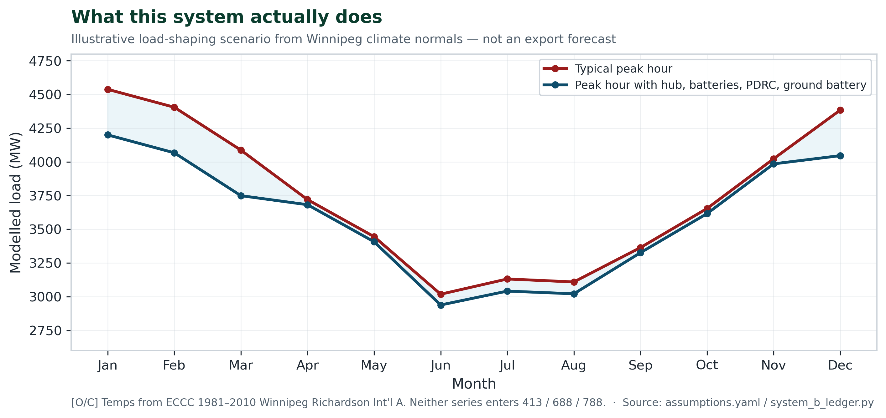
Figure 15 — Illustrative load-shaping scenario: modelled typical peak-hour load from Winnipeg climate normals — not an export forecast [O/C].
Before any of these reductions are counted, Hydro must test them against actual hourly load and weather records, extreme winter and summer conditions, drought-year water availability, battery recharge requirements, customer response, rebound demand, transmission constraints, market prices and MISO’s increasingly important winter peak.
11. Soil & water: honest phosphorus arithmetic
Lake Winnipeg’s phosphorus problem is real. Nutrient removal at NEWPCC — binding phosphorus into solids and recovering nutrient product — is how Winnipeg finally takes a point source out of the lake. In the mid-case stack that recovery is only about 130 t P/yr, roughly 4% of the ~3,050 t/yr external-load gap [E]. This energy plan does not close that gap alone. This filing attaches a binding surplus rule the Board can require: ≥35% of heat-recovery / gated-compute surplus to Lake Winnipeg phosphorus remediation as a first lien, changeable only by a 75% supermajority governance amendment with public notice — intergenerational equity as a lock [E]. Yield bands are in the mathematical appendix — not oversold here.
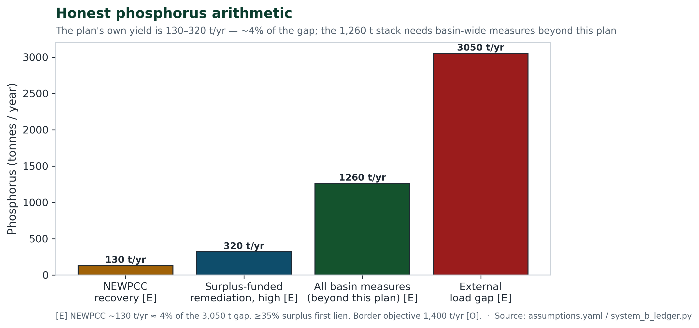
Figure 16 — Phosphorus honesty bands. Plan yield ≠ lake cure [E/O].
Objections the Board will hear — and our replies
Steelmanned objection | Reply on the record
“Batteries cannot ride a two-week vortex.” | Correct — and we never ask them to. Reservoirs hold the days; BESS holds the hours; heat shrinks the spike.
“Wastewater heat is municipal plumbing, not firm capacity.” | Sewage does not stop at −35 °C. Firmness is contractual: a 25-year Hydro–City thermal service agreement is a condition of treating hub displacement as firm [A]. Conservative case already prices effluent-only / low hub optimism.
“91% start reliability answers the 3-of-10 record.” | It answers a different question. Peak planning needs tail-hour ELCC, not annual averages. Order the study.
“ITC and cheap federal debt may not arrive.” | Every figure appears gross and net. Reference hybrid beats gas nameplate with no credit. Credits widen a gap they do not create.
“District piping will blow the budget.” | Phased behind anchor demand; can stop mid-build. Gas is one non-refundable pour. Share the open NEWPCC trench; HDD vs open-cut bounds in the mathematical appendix [E/A].
“Compute tenants are flighty.” | Bonds, boiler backup, municipal effluent base without them, and 0 MW eligible until gates clear. Flight risk is real; exposure is engineered small.
“Any data centre is hyperscale extraction.” | Reject the warehouse; keep public digital infrastructure. Heat-first, 10–20 kW, publicly accountable — Hydro / Floodway / aqueduct / MPI tradition. Eligible today: 0 MW.
“Brandon failed from deferred maintenance, not gas physics.” | Maintenance matters — and continental cold snaps show wellhead freeze-offs and valve moisture are class risks at −35 °C. ELCC settles the dispute.
“Summer PDRC pads the winter case.” | It does not. The ≈120 MW summer book is a separate seasonal benefit. Tests keep it out of 413 / 688 / 788.
12. Take action: same arithmetic, before the concrete
PUB process runs into early September. Cabinet has the last word. Premier Wab Kinew and Minister Sala can require Hydro to model sewage heat recovery and hybrid peak-shaving against the Brandon gas plan under independent cold-weather stress testing — and tell Winnipeg to put heat-recovery taps into NEWPCC before the last major contracts close.
Supporting whitepapers
Each takes a single claim from this filing and shows the work behind it. All draw on the same registry and the same corrected accounting; all are published at spirited.energy.
Whitepaper | What it shows
Real total cost, line by line | The twenty-year ledger for both plans — operations, fuel, carbon, and battery replacement behind the $4.5–6.9B and $1.5–1.8B bands.
Trenchless and HDD piping analysis | How the district loop gets built quickly and at bounded cost by sharing the open NEWPCC trench and drilling beneath streets.
Heat-host master plan | Site-level build of the hub: effluent stage first, compute reject heat gated behind the three tests.
Key-indicator scoreboard | The handful of numbers that decide the case, each with its evidence class.
Steelmanned plan | The strongest version of the opposing case, answered on the record.
THE ASK — what this filing is for
Return to the seven orders (section 7 and the executive brief). They are the CTA. Everything in this paper exists to make them the least-regret path under The Public Utilities Board Act — least-cost, safe, reliable service in the public interest. Advisors: the mathematical appendix follows.
Mathematical appendix — Board arithmetic
This appendix is part of the same filing. It states the governing relations with numbers from assumptions.yaml / System B. Thermal power (MWth) and electric power (MW) never share a headline sum.
Dual-ledger axiom
Hub thermal and net electric:
The hub that counts today is the effluent stage: delivered heat
at delivered COP 4.13 (≈3.3 units of source heat moved per unit of work — a low-lift sewage-source machine), inside the 4 °C river-safe draw. Stated assumption: displaced load is electric resistance heating (COP 1) in the tail hours; if the displaced stock were air-source heat pumps at COP 1.5–2, the credit scales to 19–25 MW — disclosed, not hidden.
Contingent compute reject heat (
) is never a firm-supply credit: netted honestly at full build it is
in the peak hour if run flat — the IT load that makes the heat must be counted. The design answer is curtailment with BTES banking: load off at peak, stored heat still serving the loop. Its winter value enters only through the demand-response line once contracted; today it carries
.
Winter accreditation [C]
Building blocks:
(two 2 h events → 1,200 MWh);
;
[A].
Margins vs shortfall
:
,
,
(MW). Reference and full cover
; conservative does not — by design. Illustrative ELCC haircut on our own resources (BESS 85%, DSM 80%):
— the reference case survives the treatment we ask the Board to apply to gas.
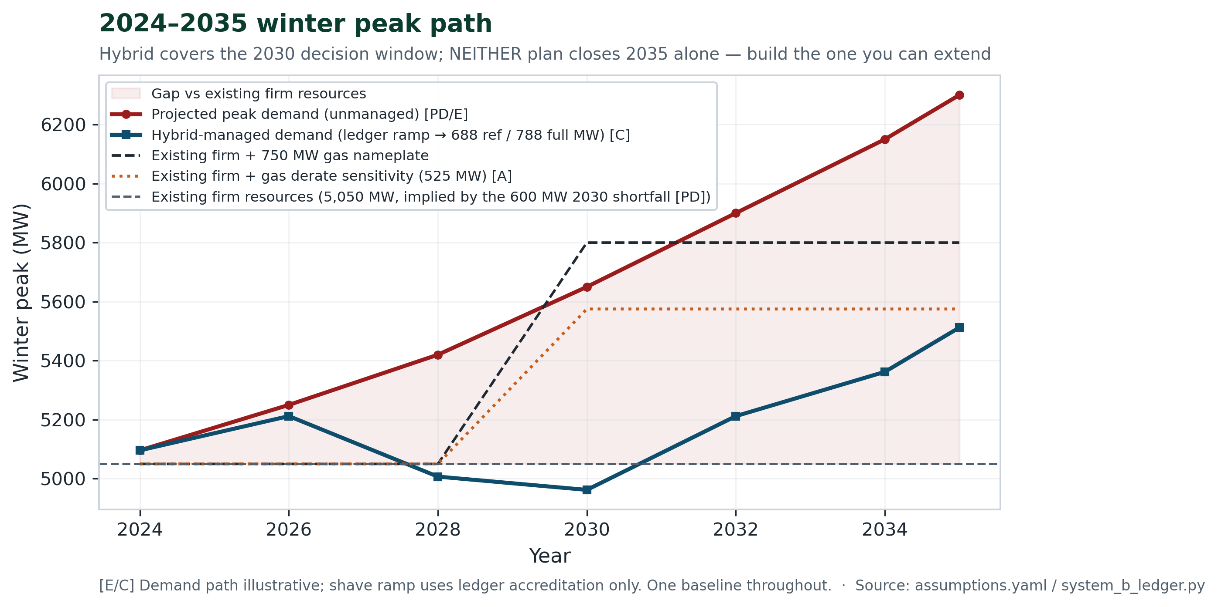
Exhibit A1 — 2024–2035 winter peak path: unmanaged demand, gas nameplate vs derate scenario, hybrid electric-ledger ramp [E/C].
Gas comparison
,
. Event-informed derate scenario (not an ELCC finding):
[A]. The 3-of-10 cold-event record [PD] is an ELCC study ask — not a flat 30% derate-as-fact.
Delivered capital intensity
Delivered cost per firm kilowatt, in $/kW:
Hybrid:
,
[A],
.
Scenario | P (MW) | Gross $/kW | Net $/kW
Conservative | 413 | 4,722 | 3,632
Reference | 688 | 2,834 | 2,180
Full | 788 | 2,475 | 1,904
Gas nameplate | 750 | 4,000 | —
Gas derate scen. | 525 | 5,714 | —
Pass gate: hybrid reference gross $/kW beats gas nameplate $/kW — no ITC, no derate assumed. The derate column is a sensitivity only.
Twenty-year bands [E/A]
,
net of the ITC. On a gross basis (ITC add-back $0.45B) the hybrid band is
and savings become
— the conclusion is unchanged. O&M, DSM payments, loop operation and BESS augmentation are itemised in the forensic accounting whitepaper. Non-overlap:
. Savings band
(net basis).
Sewage-heat physics [E]
, with
in °C — so 1 °C ≈ 9.4 MWth and 4 °C ≈ 37.6 MWth source heat. With ≈12 MW of compressor work at delivered COP 4.13, delivered hub heat is ≈50 MWth.
(source, thermal) and
(net electric credit) are different quantities that round alike — never interchange them.
Summer seasonal book — not winter firm [E]
PDRC rejects
of heat (2.4M m² × 75 W/m²); the avoided electric A/C load is
. With BTES chiller avoidance (
):
— and this quantity is excluded from
,
, and
.
System B pass predicates
All currently PASS under build_ledger().pass_report(): dual-ledger integrity; reference and full cover shortfall; $/kW and lifecycle gates; hub net < hub thermal; summer excluded from winter firm.
Reproduction: python3 research/recalculate_and_generate_all.py · registry research/assumptions.yaml.
Glossary
Term | Plain meaning
Firm capacity | Power the planner can count on for the coldest peaks
ELCC | What a resource is worth in the hours that matter
MWth vs MW | Heat vs electricity — never add
Accreditation | How much counts toward the shortfall after reliability review
NEWPCC | North End Water Pollution Control Centre
PDRC | Passive daytime radiative cooling — summer only
BTES | Seasonal borehole/aquifer heat storage

